**Process and Data Design**

**Audience**: Architects, Application and smart contract developers, Business professionals

This topic shows you how to design the commercial paper processes and their related data structures in PaperNet. Our [analysis](https://hyperledger-fabric.readthedocs.io/en/latest/developapps/analysis.html) highlighted that modelling PaperNet using states and transactions provided a precise way to understand what’s happening. We’re now going to elaborate on these two strongly related concepts to help us subsequently design the smart contracts and applications of PaperNet.

**Lifecycle**

As we’ve seen, there are two important concepts that concern us when dealing with commercial paper; **states** and **transactions**. Indeed, this is true for *all* blockchain use cases; there are conceptual objects of value, modeled as states, whose lifecycle transitions are described by transactions. An effective analysis of states and transactions is an essential starting point for a successful implementation.

We can represent the life cycle of a commercial paper using a state transition diagram:

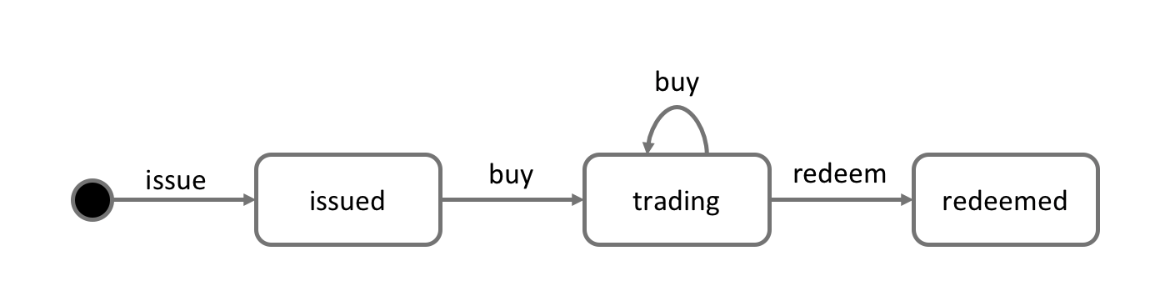 *The state transition diagram for commercial paper. Commercial papers transition between****issued****,****trading****and****redeemed****states by means of the****issue****,****buy****and****redeem****transactions.*

See how the state diagram describes how commercial papers change over time, and how specific transactions govern the life cycle transitions. In Hyperledger Fabric, smart contracts implement transaction logic that transition commercial papers between their different states. Commercial paper states are actually held in the ledger world state; so let’s take a closer look at them.

**Ledger state**

Recall the structure of a commercial paper:

 *A commercial paper can be represented as a set of properties, each with a value. Typically, some combination of these properties will provide a unique key for each paper.*

See how a commercial paper Paper property has value 00001, and the Face value property has value 5M USD. Most importantly, the Current state property indicates whether the commercial paper is issued,trading or redeemed. In combination, the full set of properties make up the **state** of a commercial paper. Moreover, the entire collection of these individual commercial paper states constitutes the ledger [world state](https://hyperledger-fabric.readthedocs.io/en/latest/ledger/ledger.html#world-state).

All ledger state share this form; each has a set of properties, each with a different value. This *multi-property* aspect of states is a powerful feature – it allows us to think of a Fabric state as a vector rather than a simple scalar. We then represent facts about whole objects as individual states, which subsequently undergo transitions controlled by transaction logic. A Fabric state is implemented as a key/value pair, in which the value encodes the object properties in a format that captures the object’s multiple properties, typically JSON. The [ledger database](https://hyperledger-fabric.readthedocs.io/en/latest/ledger/ledger.html#ledger-world-state-database-options) can support advanced query operations against these properties, which is very helpful for sophisticated object retrieval.

See how MagnetoCorp’s paper 00001 is represented as a state vector that transitions according to different transaction stimuli:

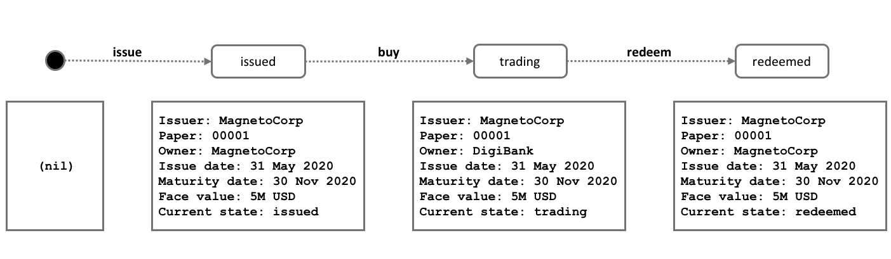 *A commercial paper state is brought into existence and transitions as a result of different transactions. Hyperledger Fabric states have multiple properties, making them vectors rather than scalars.*

Notice how each individual paper starts with the empty state, which is technically a [nil](https://en.wikipedia.org/wiki/Null_(SQL)) state for the paper, as it doesn’t exist! See how paper 00001 is brought into existence by the **issue** transaction, and how it is subsequently updated as a result of the **buy** and **redeem** transactions.

Notice how each state is self-describing; each property has a name and a value. Although all our commercial papers currently have the same properties, this need not be the case for all time, as Hyperledger Fabric supports different states having different properties. This allows the same ledger world state to contain different forms of the same asset as well as different types of asset. It also makes it possible to update a state’s structure; imagine a new regulation that requires an additional data field. Flexible state properties support the fundamental requirement of data evolution over time.

**State keys**

In most practical applications, a state will have a combination of properties that uniquely identify it in a given context – it’s **key**. The key for a PaperNet commercial paper is formed by a concatenation of the Issuer and paper properties; so for MagnetoCorp’s first paper, it’s MagnetoCorp00001.

A state key allows us to uniquely identify a paper; it is created as a result of the **issue** transaction and subsequently updated by **buy** and **redeem**. Hyperledger Fabric requires each state in a ledger to have a unique key.

When a unique key is not available from the available set of properties, an application-determined unique key is specified as an input to the transaction that creates the state. This unique key is usually with some form of [UUID](https://en.wikipedia.org/wiki/Universally_unique_identifier), which although less readable, is a standard practice. What’s important is that every individual state object in a ledger must have a unique key.

*Note: You should avoid using U+0000 (nil byte) in keys.*

**Multiple states**

As we’ve seen, commercial papers in PaperNet are stored as state vectors in a ledger. It’s a reasonable requirement to be able to query different commercial papers from the ledger; for example: find all the papers issued by MagnetoCorp, or: find all the papers issued by MagnetoCorp in the redeemed state.

To make these kinds of search tasks possible, it’s helpful to group all related papers together in a logical list. The PaperNet design incorporates the idea of a commercial paper list – a logical container which is updated whenever commercial papers are issued or otherwise changed.

**Logical representation**

It’s helpful to think of all PaperNet commercial papers being in a single list of commercial papers:

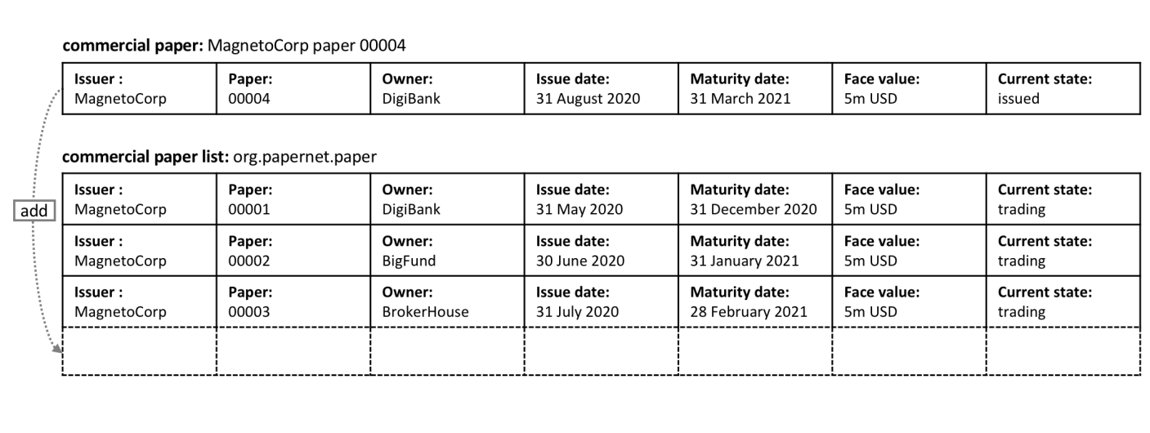 *MagnetoCorp’s newly created commercial paper 00004 is added to the list of existing commercial papers.*

New papers can be added to the list as a result of an **issue** transaction, and papers already in the list can be updated with **buy** or **redeem** transactions. See how the list has a descriptive name: org.papernet.papers; it’s a really good idea to use this kind of [DNS name](https://en.wikipedia.org/wiki/Domain_Name_System) because well-chosen names will make your blockchain designs intuitive to other people. This idea applies equally well to smart contract [names](https://hyperledger-fabric.readthedocs.io/en/latest/developapps/contractname.html).

**Physical representation**

While it’s correct to think of a single list of papers in PaperNet – org.papernet.papers – lists are best implemented as a set of individual Fabric states, whose composite key associates the state with its list. In this way, each state’s composite key is both unique and supports effective list query.

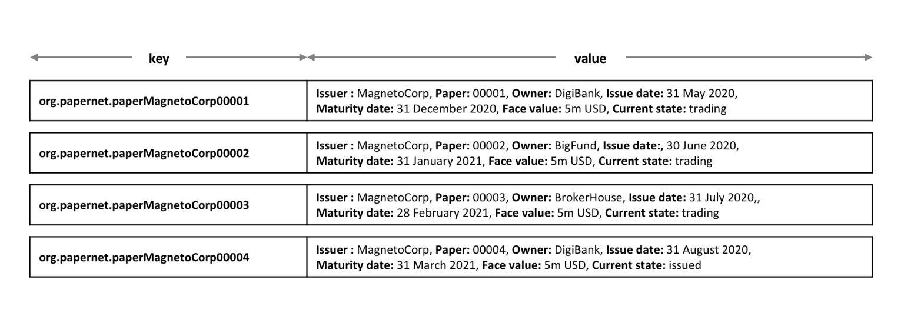 *Representing a list of PaperNet commercial papers as a set of distinct Hyperledger Fabric states*

Notice how each paper in the list is represented by a vector state, with a unique **composite** key formed by the concatenation of org.papernet.paper, Issuer and Paper properties. This structure is helpful for two reasons:

* It allows us to examine any state vector in the ledger to determine which list it’s in, without reference to a separate list. It’s analogous to looking at set of sports fans, and identifying which team they support by the colour of the shirt they are wearing. The sports fans self-declare their allegiance; we don’t need a list of fans.
* Hyperlegder Fabric internally uses a concurrency control mechanism to update a ledger, such that keeping papers in separate state vectors vastly reduces the opportunity for shared-state collisions. Such collisions require transaction re-submission, complicate application design, and decrease performance.

This second point is actually a key take-away for Hyperledger Fabric; the physical design of state vectors is **very important** to optimum performance and behaviour. Keep your states separate!

**Trust relationships**

We have discussed how the different roles in a network, such as issuer, trader or rating agencies as well as different business interests determine who needs to sign off on a transaction. In Fabric, these rules are captured by so-called [**endorsement policies**](https://hyperledger-fabric.readthedocs.io/en/latest/developapps/endorsementpolicies.html). The rules can be set on a chaincode granularity, as well as for individual state keys.

This means that in PaperNet, we can set one rule for the whole namespace that determines which organizations can issue new papers. Later, rules can be set and updated for individual papers to capture the trust relationships of buy and redeem transactions.

In the next topic, we will show you how to combine these design concepts to implement the PaperNet commercial paper smart contract, and then an application in exploits it!